

Faculty of Engineering Cairo University

Computer Engineering Department

Fall 2020

Lipify

Image Processing Project Report

**Team Members:**

Ahmed Mohamed Salah

Mustafa Abd El-Gawad Mohamed

Mustafa Mufeed Abdul Majeed

# Project Idea and Need:

The idea behind this project is making the computer be able to extract the face of a given person’s live stream. The need behind the project is that it will be a great help in our graduation project which will be about lip reading and translating the detected words to text or audio.

# Informative block diagram

**Input**

Live stream

**Processing (Methods)**

Analyze skin and extracting aspect ratio of region of interest

**Output**

Filters applied on regions of the face

# Any needed non primitive functions

* Skimage
* OpenCV

# Additional Comments

With the constraint of not using any learning algorithms, we implemented our own skin segmentation, face extraction. And because the requirement were not clear from the start we implemented 2 projects before knowing which implementation would be accepted.

# Scientific Papers as reference

“Face Detection using Skin Tone Segmentation” by A. Ajith

“Combining Edge Detection with Region Segmentation” by S. Usman

# Used Algorithms

* Skin Tone Segmentation using HSV, RGB, and YCbCr
* Morphological Operations to fill holes in face
* Using connected components to get face boundaries
* Blurring using Gaussian Filter
* Sobel Edge Detection
* Getting face features using aspect ratio of bounding box (numbers calculated using papers)

# Experiment results and analysis

We are able to detect human skin of multiple people. Then we extract the face. And finally apply 3 filters.

# Work division between team members

|  |  |
| --- | --- |
| **Team Member** | **Work Load** |
| Ahmed Mohamed Salah | 33% |
| Mustafa Abd El-Gawad Mohamed | 33% |
| Mustafa Mufeed Abdul Majeed | 33% |

# Accuracy and Performance

Accuracy was over 50%.

Performance is acceptable.

# Conclusion

We managed to detect the face using pure image processing. And from the face, we managed to get the mouth aspect ratio in order to place our filters.

# Screenshots

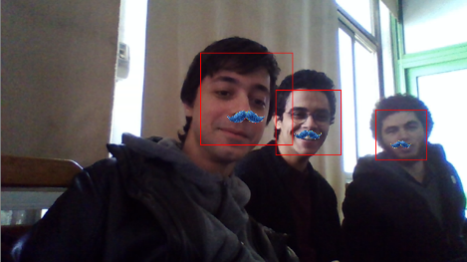

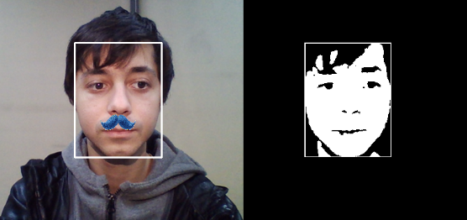

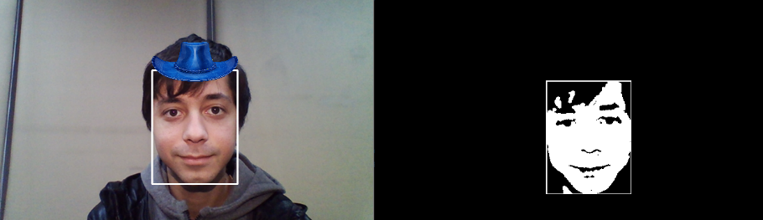

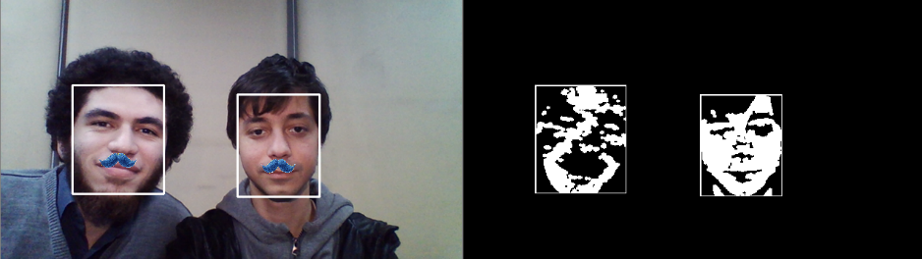

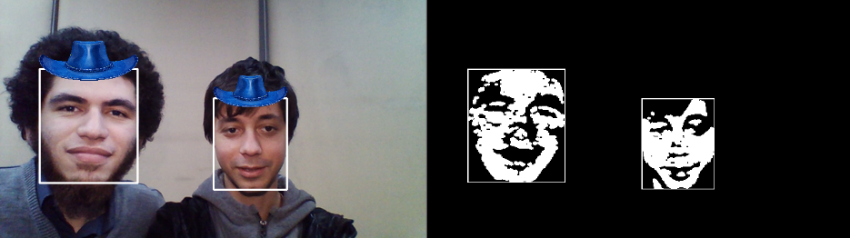

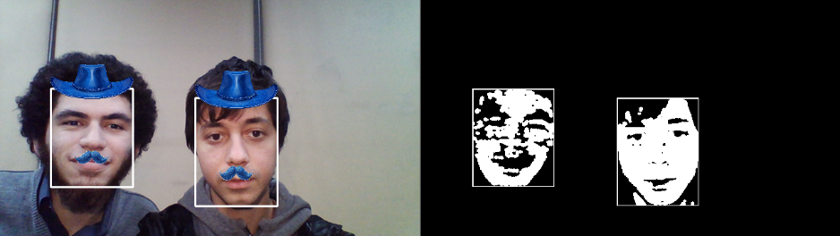

# References

* <https://ieeexplore.ieee.org/document/6141217>
* https://link.springer.com/chapter/10.1007/978-3-642-14061-7_2